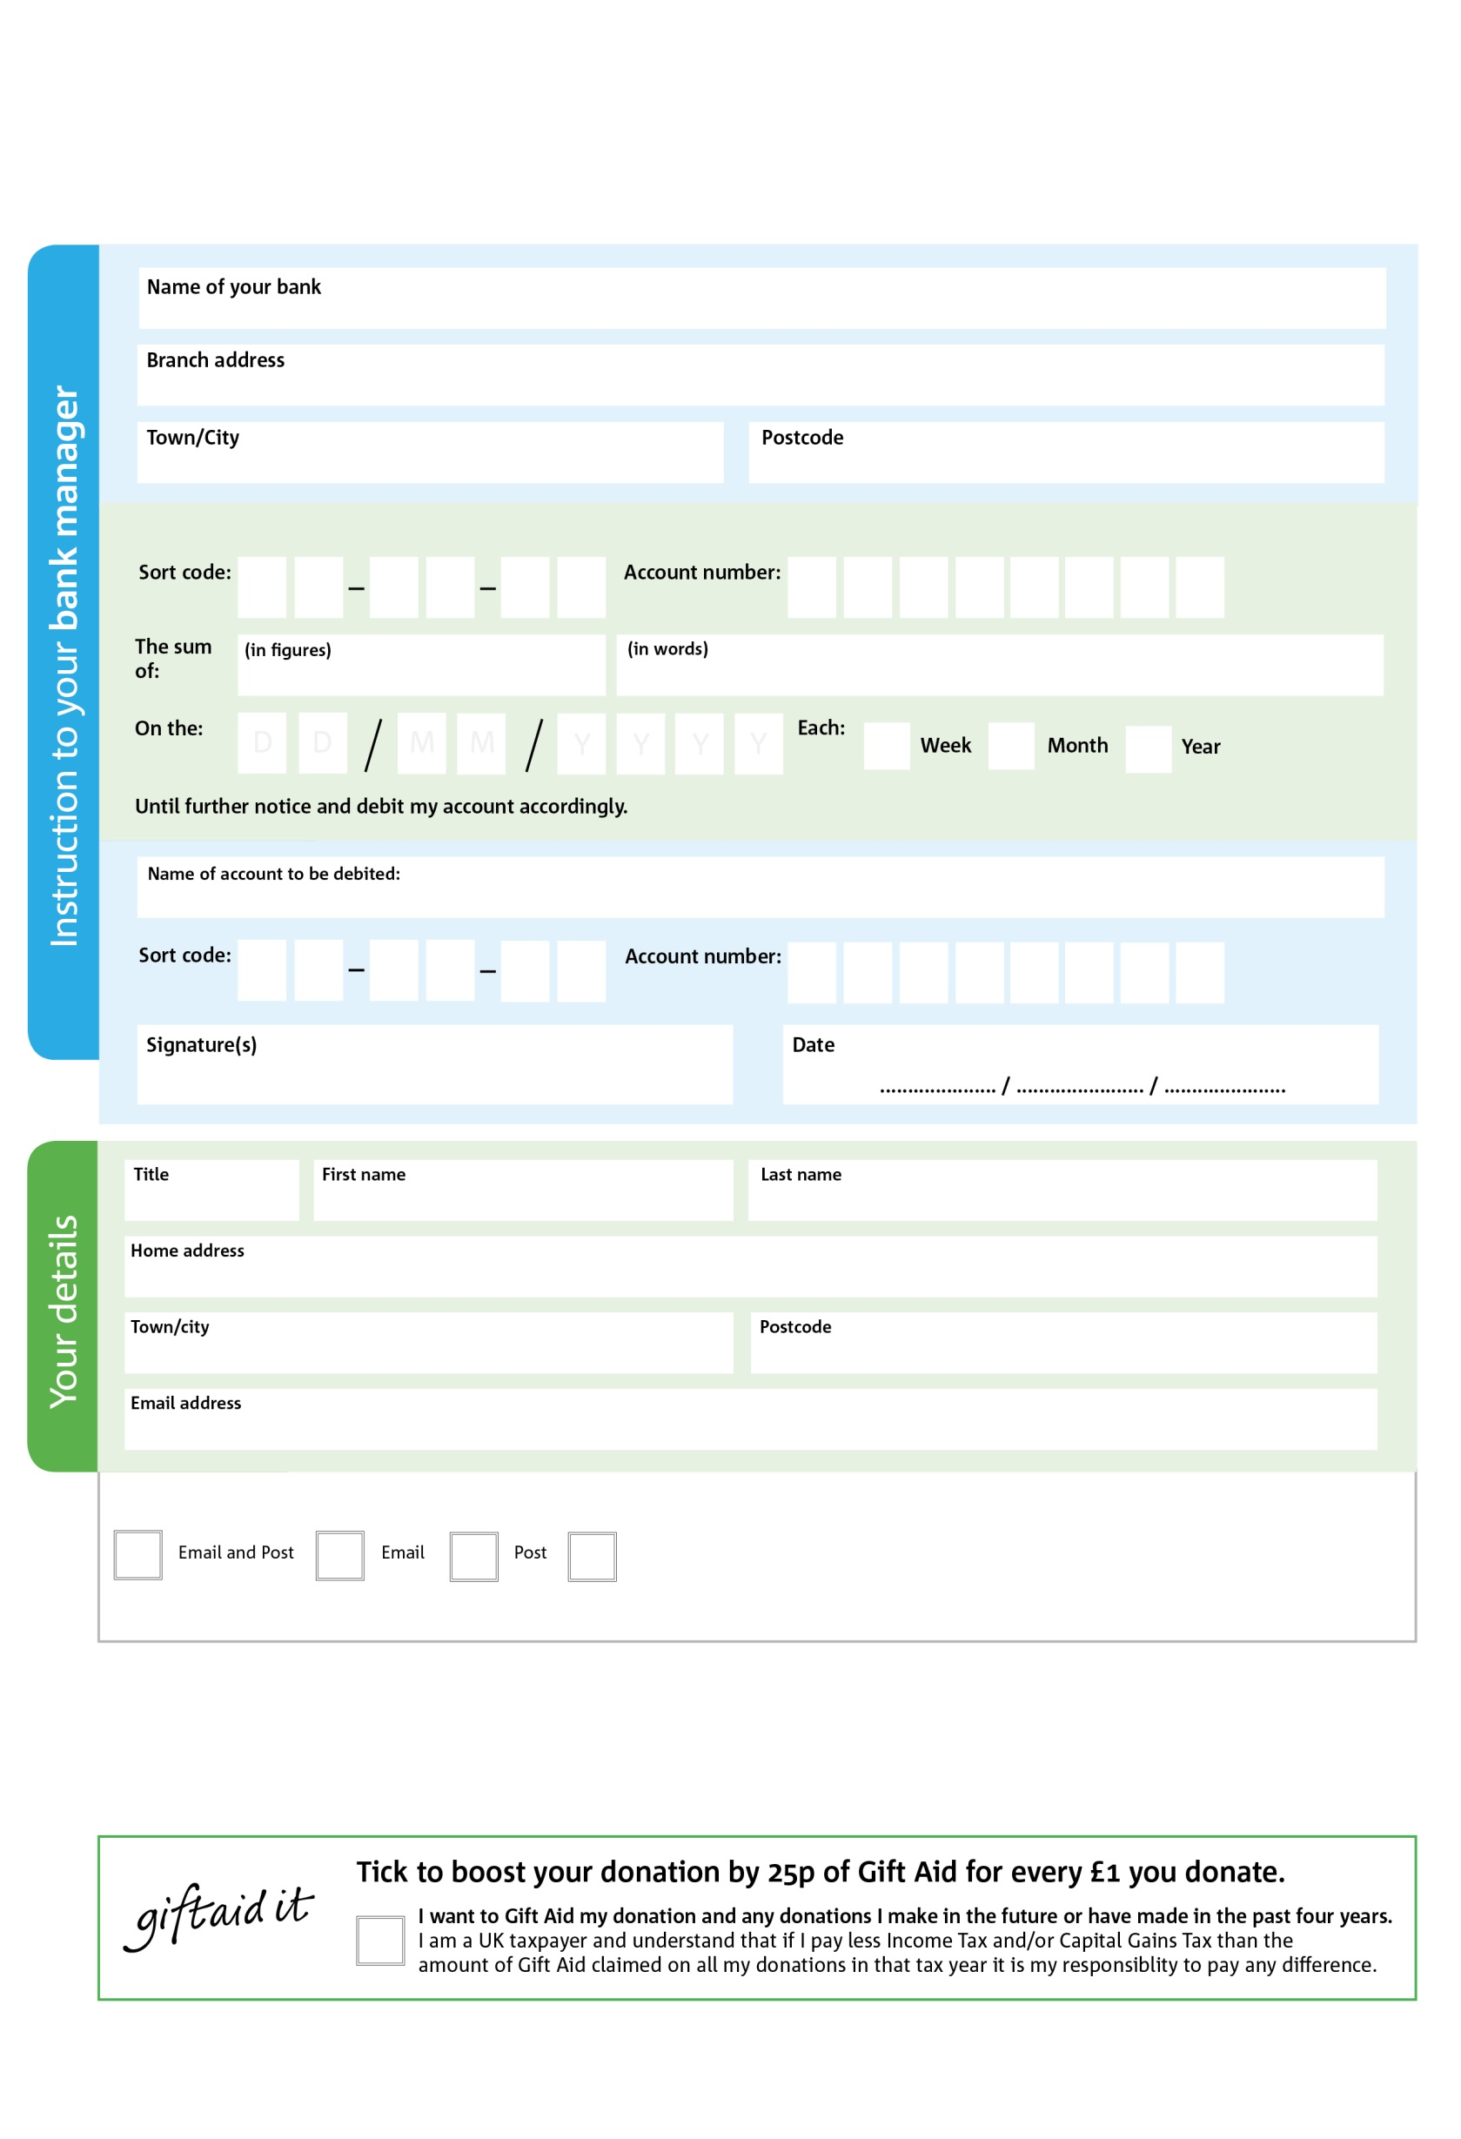

POSTAL ADDRESS:Richmond Foodbank,The Vineyard Community Centre, The Vineyard, Richmond, Surrey. TW10 6AQ

Reg. Charity No:1143951 | Reg. in England & Wales 7669793

X

V

X

V

X

V

X

V

X

V

X

V

X

V

X

V

**Please pass this form onto the foodbank, using the foodbank’s address at the bottom, who will save a copy for their records.   
They will then send it onto your named bank or building society.**

X

X

X

X

X

X

We would love to keep you up to date with information about Richmond Foodbank. Please tick your preference:

You can change your preferences any time by or emailing us at peter@vineyardcommunity.org

I do not wish to receive future communications from Richmond Foodbank

Please pay Richmond Foodbank,

**Data protection**

*Richmond Foodbank is committed to protecting your privacy and will process your personal data in accordance with current Data Protection legislation. Richmond Foodbank collects information to keep in touch with you and supply you with information relating to our work. To unsubscribe from our newsletter, send a message to the email address above with the word unsubscribe in the subject line. A full data privacy statement for financial donors is available from the foodbank on request.’*

**Standing Order Mandate**

**Richmond.foodbank.org.uk**

You can change your preferences any time by contacting us on XXXXXXXXXXX or emailing us at XXXX@XXXXXXXXXX.foodbank.org.uk

I do not wish to receive future communications from XXXXXX Foodbank